Javascript Exam

**Program - 1:**

Write a function for given formula:

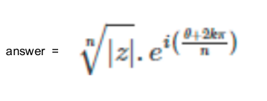

**Code**

let n = 2, z, i = 0.1, k = 3, theta = 1, e = 1;

z = Math.abs(-4);

let c = Math.sqrt(z);

let first = (Math.pow(Math.abs(-4)), 1 / n);

let second = (Math.exp((i) * ((theta + (2 * k * Math.PI)) / n)));

let answer = first * second;

console.log(answer);

**Output**

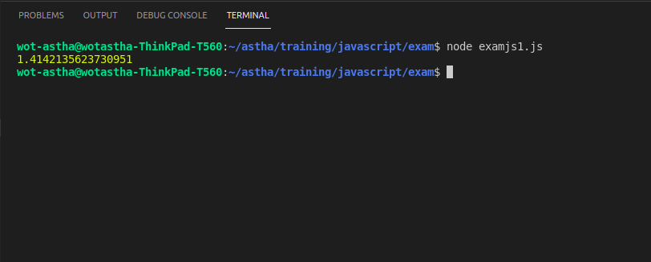

**Program - 2:**

Create two arrays one containing numbers from 0-9 and the second containing letters from

a-e. Create 10 random pairs of 3 alphanumeric and store them in an array.

Input:

numberArray = [0,1,2,3,4,5,6,7,8,9]

letterArray = [‘a’,’b’,’c’,’d’,’e’]

Output:

[5ab, ba6, 23a, …, ec0]

**Code**

numberArray = [0, 1, 2, 3, 4, 5, 6, 7, 8, 9]

letterArray = ["a", "b", "c", "d", "e"]

randomArray = []

let concArray = numberArray.concat(letterArray);

//console.log(concArray);

for (i = 0; i < 10; i++) {

let x = Math.floor(Math.random(numberArray) * 15);

let y = Math.floor(Math.random(letterArray) * 15);

let z = Math.floor(Math.random(concArray) * 5);

randomArray.push(concArray[x] + " " + concArray[y] + " " + letterArray[z]);

}

console.log(randomArray);

**Output**

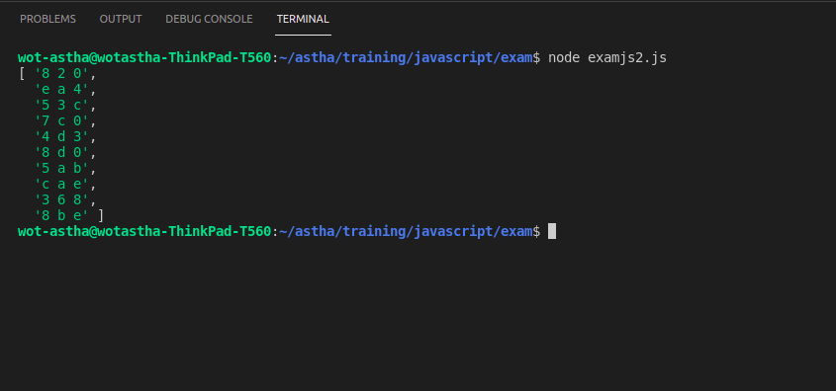

**Program - 3:**

Take two input array and Create final array of 100 random JSON elements.

Each elements contains three value:

Category: Random from given input category array

Age: Random from given input age array

Visitors: Any random number between 0 to 100

**Code**

//

var category = [

"movie",

"news",

"education",

"sports ",

"politics"

]

var age = [

"teenager",

"adult"

]

var outputarray = [];

for (i = 0; i < 100; i++) {

let x = age[Math.floor(Math.random(age) * age.length)];

let y = category[Math.floor(Math.random() * category.length)];

let z = Math.floor(Math.random() * 100);

var outputobj = { age: x, category: y, visitors: z };

console.log(outputobj);

}

**Output**

